**УДК 616.928.8+616.379-008.64+616.33-002]:316.774**

**AWARENESS OF DENGUE FEVER, DIABETES AND GASTRITIS AMONG PEOPLE OF DIFFERENT NATIONALITIES**

***Dona Kaveesha Ranasinghe, Ayon Silva***

**Scientific adviser: *Faschenko Ya.I.***

**Educational institution "Gomel State Medical University"**

**Republic of Belarus, Gomel**

***Introduction.***

In the idea of facing global health challenges and acknowledging the awareness of the publics exposure to some of the common prevalence of such diseases that is vital for shaping the health policies and evoking intervention strategies. Dengue Fever, Gastritis and Diabetes are the diseases that varies and affects in a significant quantity based on different nations and their methods of healthy lifestyle [1].

In an increasingly interconnected world, understanding the prevalence of diseases across different nations is paramount for global health initiatives. Epidemiological studies provide crucial insights into the distribution and burden of diseases, enabling policymakers and healthcare professionals to formulate targeted interventions.

***Aim***

The primary aim of this research is to analyze the public awareness of Dengue Fever, Gastritis and Diabetes based on the online survey conducted and to compare the results to identify potential gaps in the knowledge and public health strategies.

***Materials and Methods of research***

An online survey was conducted targeting individuals ranging from 18-75 years old, with a broad demographic representation of Dengue Fever, Gastritis, and Diabetes awareness. The questionnaire was based on symptoms, causes, preventive measures and treatment options. Overall, responses were gathered from Sri Lanka (85.6%), India (10%) and Syria (4.4%).

***The results of the research***

The prevalence of diseases among different nationalities is shown in Figure 1.

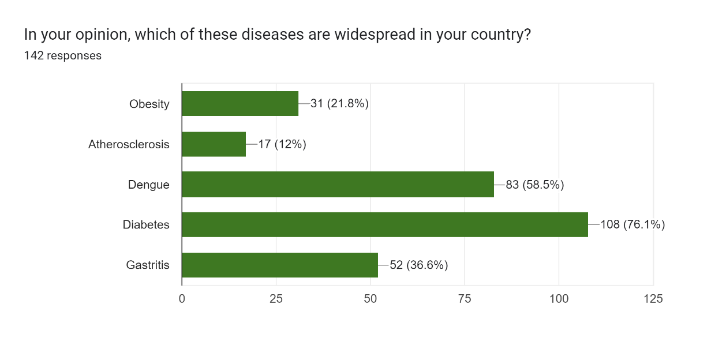

**Figure 1** **— Leading diseases in different nations**

The following findings were obtained from the survey regarding their level of awareness on Dengue Fever, Gastritis and Diabetes among respondents. Dengue Fever awareness — 80.8% of respondents correctly high fever as a symptom, 69.2% were aware of muscle joint pain, 89.2% correctly identified mosquito bite as the primary cause of dengue and for preventive measures – 57.1% used mosquito nets, 46.8% applied mosquito repellents.Gastritis awareness – 79.4% identified stomach pain as a common symptom, 72.2% recognized spicy foods as a risk factor, 63.5% recognized stress a cause, but only 26.2% were aware of H.Pylori infection as a significant cause, preventive measures 54% involved in avoiding spicy food. Diabetes awareness – 51.6% identified excessive thirst as a symptom and 56.3% recognized unexplained weight loss, 61.9% chose genetics as the main cause, with 60.3% recognizing obesity as a risk factor, and 66.7% used insulin as a part of their treatment and 59.5% followed a balanced diet for management.

Based on the data received it can be compared with the global health standards. The high level of awareness about mosquito bites as the primary cause of dengue aligns with global health standard. According to the World Health Organization (WHO), Dengue is predominantly transmitted by the Aedes aegypti mosquito, and the prevention of mosquitos’ bites is key to controlling the disease (WHO, 2020). However, limited awareness of climate change as a contributing factor indicates a knowledge gap. Increasing global temperature and changes in rainfall patterns are accelerating the spread of Dengue Fever in regions like Southeast Asia and Latin America [5].

The respondents’ recognition of spicy foods and stress as cause of Gastritis is consistent with research highlighting their role in exacerbating gastrointestinal conditions. However, a significant knowledge gap remains regarding H. pylori infection rates are higher in Asia, particularly in countries like Sri Lanka and India, and this bacterial infection plays a critical role in Gastritis development [2,3,4].

The survey data showed a strong understanding of obesity and genetics as leading causes of Diabetes, line with finding from the International Diabetes Federation, which cites these factors as the primary contributors to the rising prevalence of Type 2 Diabetes globally [3]. However, stress was still identified by some respondents as a primary cause, suggesting a gap in understanding the complex relationship between insulin resistance, lifestyle, and genetics. Globally, Dengue Fever awareness has been strengthened in high-risk regions through target health campaigns, particularly in Southeast Asia [1,2]. In contrast, Gastritis awareness remain uneven with lower recognition of H. pylori infection in countries where it is most prevalent. Public health campaigns should place more emphasis on this aspect [3,4]. Diabetes awareness is higher in countries with more developed healthcare systems, but misconception about stress as a primary cause persist [4].

***Conclusion***

In conclusion, public awareness of Dengue Fever, Gastritis and Diabetes is varied with stronger knowledge of the causes and preventive measures for Dengue Fever and Diabetes while gaps remain, particularly concerning Gastritis and the bacterial role of H. Pylori. Global health campaigns can play a pivotal role in bridging these knowledge gaps particularly regarding the environmental factor influencing Dengue and lifestyle factors contributing to Diabetes. Increased focus on education about H. Pylori for Gastritis and promoting lifestyle intervention for Diabetes can enhance disease prevention strategies worldwide.

**LITERATURE**

1.Global Burden of diseases by University of Washington // Mode of access: <https://www.healthdata.org/research-analysis/gbd> - Date of Access: 20/02/2024

2. Survey on Prevalence of diseases according to countries // Mode of access : <https://docs.google.com/forms/d/1hwYxXShgB_JOw6fMjVVKjWThRCYzMFQKrdloshj4uiU/edit#responses> – Date of Access : 05/02/2024

3. Global, regional, and national incidence, prevalence, and years lived with disability for 328 diseases and injuries for 195 countries, 1990–2016: a systematic analysis for the Global Burden of Disease Study 2016. //Mode of access: <https://www.sciencedirect.com/science/article/pii/S0140673617321542> - Date of Access: 01/02/2024

4. When did obesity increase? How do rates vary across the world? What is the health impact? By [Hannah Ritchie and Max Roser](https://ourworldindata.org/team)// Mode of access: <https://ourworldindata.org/obesity> -Date of access :03/02/2024

# 5.Dengue worldwide overview by the European Centre for Disease Prevention and Control //Mode of access: <https://www.ecdc.europa.eu/en/dengue-monthly> -Date of access:02/03/2024